Our Ref. SP/sp/09/355/62
January, 2020

Dear Sir/Madam

NOMINIATION
FIABCI-Thai PRIX D’EXCELLENCE AWARDS 2020

Greetings from FIABCI-Thai. We are pleased to inform you that FIABCI-Thai officially announces the holding of the FIABCI-Thai PRIX D’EXCELLENCE AWARDS 2020 being held to give recognition to outstanding best real estate projects in Thailand.

In this regard, it is our pleasure to inform you that you have been nominated for this prestigious award. Kindly inform us of your acceptance of your nomination by returning the duly accomplished nomination form thru email: info@fiabci-thai.org. Attached is a copy of the guidelines for joining and the categories for your reference.

We have invited respected people in the field of real estate and other related disciplines, business and academy (local and foreign) to comprise the panel of judges. Your entry/entries will be judged based on the following criteria: General Description of Project, Architecture and Design, Development and Construction, Finance, Marketing, Environmental Impact, Safety & Maintenance, and Community Benefits.
Winners of the said awards shall be endorsed to the FIABCI-Thai PRIX D’EXCELLENCE AWARDS 2020 for the best international real estate projects (14 categories) to be held in Paris, France in May 2021, during the 72nd FIABCI World Real Estate Congress, an annual event held by The International Real Estate Federation (FIABCI) based in Paris. The winners of FIABCI World Prix d’Excellence Awards will gain access to international platform and extensive FIABCI network of more than 70 countries and over 120 professional organizations worldwide. You can visit www.fiabci.org or www.fiabciprix.com for more information.

Please do not hesitate to contact the undersigned or Mr. Sunchai of the FIABCI-Thai Secretariat at Tel. 02.295.3905 or email: info@fiabci-thai.org

Very truly yours,



Sopon Pornchokchai, PhD D.FIABCI MRICS
President, FIABCI-Thai

FIABCI-Thai PRIX D’EXCELLENCE AWARDS 2020
GUIDELINES FOR JOINING

IMPORTANT INSTRUCTIONS

Candidates wishing to participate in the FIABCI-Thai PRIX D’EXCELLENCE AWARDS 2020 should send their application to the FIABCI-Thai by June 30, 2020.

A. RULES AND CONDITIONS OF ENTRY

- The person submitting the project must be either the owner, developer or person with overall executive responsibility for the project, or alternatively a duly authorized professional acting on his/her behalf (architect, public relations company, etc.)

- The Awards Committee/Judges reserves the right not to confer an award in any given category if, in its opinion, no project submitted in that category fulfils the judging criteria to a sufficiently high standard.

- The project must have been completed and fully operational for at least 12 months before the deadline for receipt of Application Forms. If the project comprises several phases, at least 1 phase must be complete and operational before submitting.

- There will be no reimbursement of expenses relating to the submission of a project.

- FIABCI-Thai reserves the right to use the photos and extracts from the submissions of the winning projects for the Awards. Photos and video footage from the submissions may be used in the final presentation and/or magazine/brochure.

- The awards will be announced and presented during the Awards Gala Night. The winning projects will be notified prior to this time and the award winners must attend the Awards Ceremony to receive their award. The committee reserves the right to withdraw the awards, if the winners refused to attend the Awards Ceremony.

- Press releases announcing the award winners will be distributed to the media.

- Winning projects are refrained from circulating press releases concerning the results until AFTER the official announcement has been made at the Awards Gala Night.

B. INSTRUCTIONS FOR SUBMISSION

- Relevant Dates:
Submission to FIABCI-Thai Secretariat: June 30, 2020 (Tuesday)
Evaluation/Site Inspection: July 10-22, 2020
Awards Ceremony: August 4, 2020 (Tuesday)

- Format of submission:
See the Appendix.

- Language of submission:
English.

- Announcements:
Announcements of winners will not be made until after the Awards Gala Night Presentation Ceremony on Tudsday, August 4, 2020 at the Arnoma Grand Hotel where the President of FIABCI International and other international guests would be invited to join.

- Entries:
A company can enter as many projects as it chooses. The awards are made on the basis of the overall excellence of the development.

- Categories of Awards:

6.1 Environmental (Rehabilitation / Conservation) Category - Project that rehabilitates an environment or to conserve existing environment.

6.2 Heritage (Restoration / Conservation) Category - Restoration or conservation old buildings that have been identified for Heritage Conservation.

6.3 Hotel Category - Business type or leisure type, service apartments that are strictly operated as hotel, etc.

6.4 Convention Category – Convention Centers, Exhibition Halls

6.5 Industrial Category - For industrial building, industrial parks, technology parks, warehouse, factory, workshop, etc.

6.6 Master Plan Category - For a development concept plan, i.e. township development and housing estate development.

6.7 Office Category - For office buildings and office parks

6.8 Public Infrastructures/Amenities Category - Project developed by public fund: government buildings, hospitals, road, bridges, stadium, etc.

6.9 Residential Condominiums Category - Owner-occupied Apartments.

6.10 Residential (Low Rise) Category - Housing projects: detached houses, semi-detached houses, townhouses, shophouses

6.11 Affordable Housing - Housing for the lower income group.

6.12 Resort Category - Beach resorts, hill resorts, theme park, marinas, etc.

6.13 Retail Category - Mall, shopping centres, hypermarket, etc

6.14 Rural Development Category - Forestry, farm developments, etc.

6.15 Specialised Project (Purpose Built) Category - For purpose built building, i.e. international school, airport, etc.

6.16 Sustainable Development Category - For energy saving project, i.e. save energy feature, building allow more natural lighting, conserve or harvest rain water for use.

- Judging Criteria
The following are the judging criteria
Category | Considerations
Hotel Category | • General Description of Project  • Architecture and Design  • Development and Construction  • Financial and Marketing  • Environmental Impact  • Community Benefits
Convention Category
Industrial Category
Office Category
Public Infrastructures/Amenities

Residential Condominium
Residential (Low Rise) Category
Affordable Housing
Resort Category
Retail Category
Homestead Development
Specialized Project Category
Master Plan Category | • General Description of Project  • Preparatory Phase of the Project  • Financial Considerations  • Authorities Approval  • Implementation  • Environmental Impact
Environmental (Rehabilitation/Conservation) Category | • General Description of Project  • Planning and Design  • Implementation  • Result and Environmental Impact  • Financial and Benefits to Community
Heritage  (Restoration/Conservation)  Category | • General Description of Project  • Architecture and Design  • Implementation Stage  • Financial and Marketing  • Community Benefits and Environment Impact
Sustainable Development Category | • General Description of Project  • Architecture and Design  • Development and Construction  • Financial and Marketing  • Environmental Impact

- Contents of Submission
A) An Application letter with a text describing the project in 100 words which will be used in the magazine/brochure when your project win.
B) Project Details, one hard copy and one CDs (Word file/JPEG/video in DVD format)

- Entry Fee
A contribution towards handling costs is required for each project.
1.Participation cost is fixed at 10,000 baht per individual project (non-refundable).
2.Winners of the awards will have to contribute another 20,000 baht per project for printing costs of the fiabci-thai 2020 prestigious book of record (4 colored advertisement) and another 20,000 baht for the table (10 seats) at the ceremony. The fiabci-thai 2020 prestigious book of record will be distributed to government, banks and other institutions involved and each winner will also receive 50 copies.

- Entry Fee Method of Payment
Global Real Estate Trade Association (FIABCI-Thai)
Thanachart Bank Public Company Limited (TBANK)
Account Number: 008-6-11733-8 Central Rama 3
SWIFT CODE : THBKTHBK

FIABCI: INTERNATIONAL REAL ESTATE FEDERATION

FIABCI is the French acronym for "Federation Internationale des Administrateurs de Bien-Conselis Immobiliers", which means "The International Real Estate Federation". Founded in 1951 in Paris, In its 68 years of existence, FIABCI has built an enviable reputation. FIABCI is a worldwide business networking organization for all professionals associated with the real estate industry.

It represents the world's real estate professions through its Special Consultative Status with the Economic and Social Council (ECOSOC) of the United Nations. FIABCI is a member of the International Ethics Standards Coalition and signed off on the 10 Principles of the UN Global Compact. FIABCI's role in the United Nations is to make recommendations and provide advice on matters such as property rights, housing for the poor and money laundering.

FIABCI has provided access and opportunities for real estate professionals interested in gaining knowledge, sharing information and conducting international business with each other. With chapters currently operating in more than 60 countries, FIABCI represents every discipline in the industry and links thousands of real estate professionals worldwide.

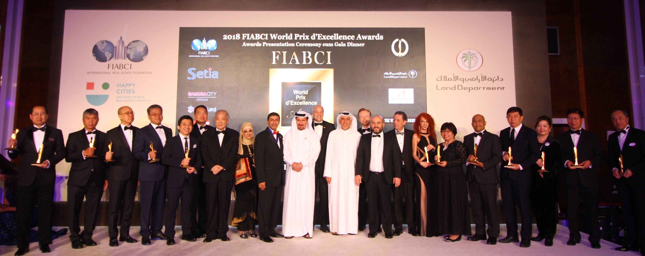

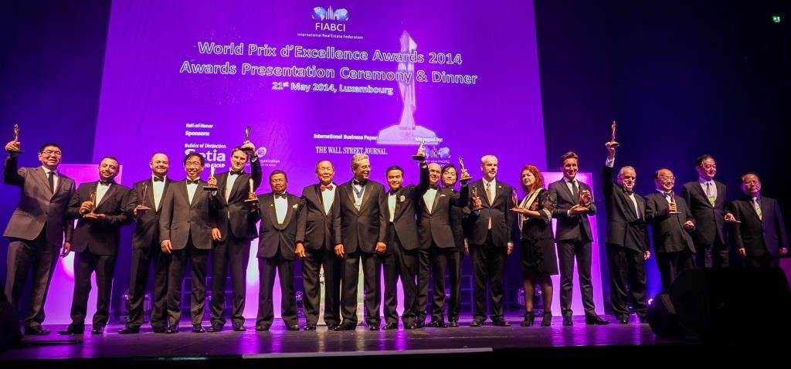
FIABCI-Thai PRIX D’EXCELLENCE AWARDS 2019
July 23, 2019, the Swissotel Bangkok Ratchada

The following was the FIABCI-Thai PRIX D’EXCELLENCE AWARDS 2019 on Tuesday, July 23, 2019 at the Swissotel Bangkok Ratchada where a lot of honorable and distinguished guests from around the world came to our event.

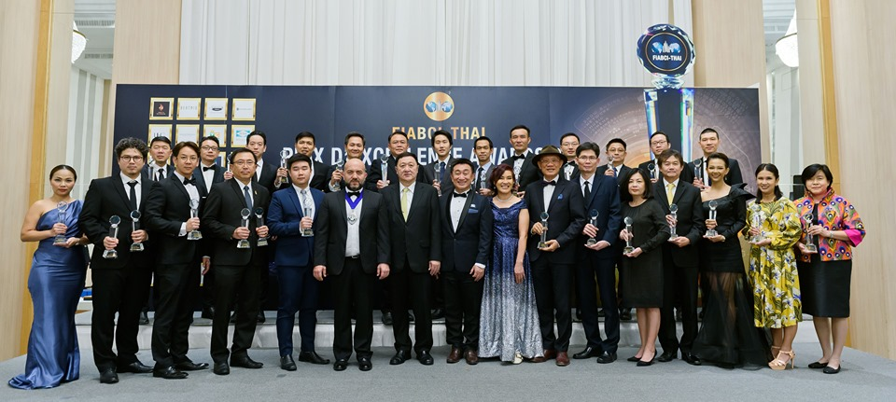

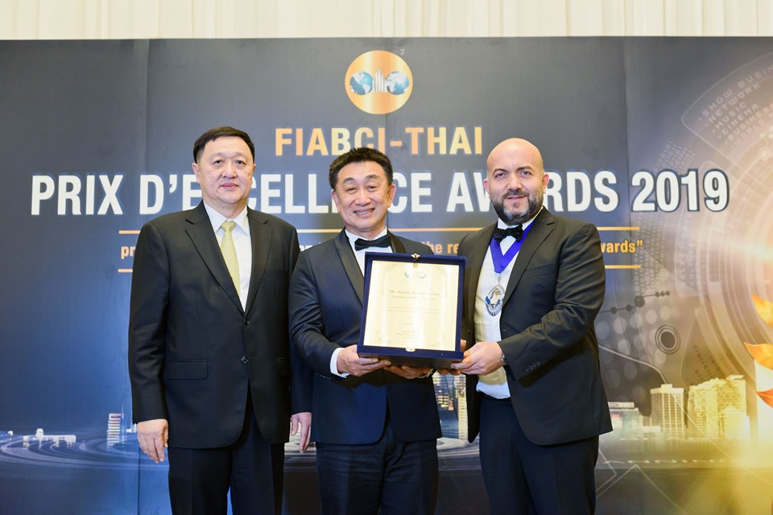
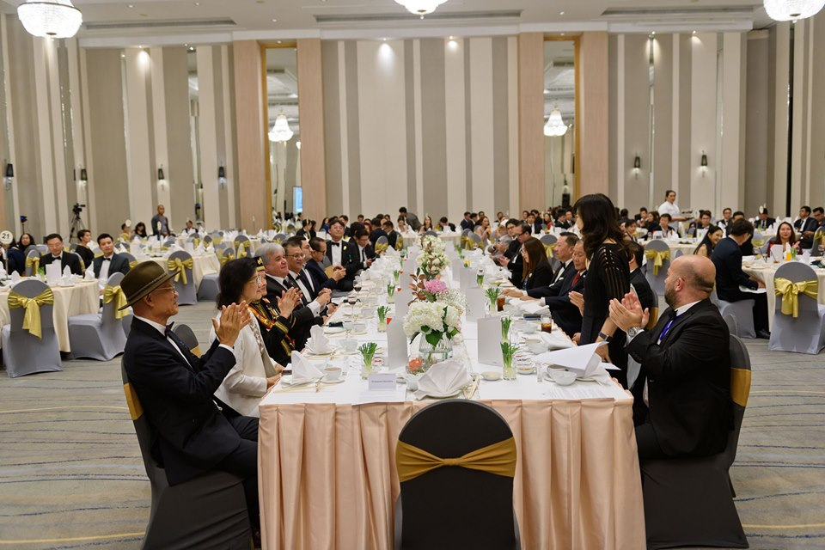
NOMINATION FORM
FIABCI-Thai PRIX D’EXCELLENCE AWARDS 2020

Email to: info@fiabci-thai.org

_____ YES, our company is interested and hereby accepting our nomination for the FIABCI-Thai PRIX D’EXCELLENCE AWARDS 2020*

Name: Prefix Name:
Position:
Company:
Address:

Signature

Contact Person: Prefix Name:
Phone No.: Fax No.:
Mobile No.: Email:

Project Name:
Category:

Entry Fee: Baht 10,000 by transfering to:
Bank: Thanachart Bank Public Company Limited (TBANK)
Central Rama 3 Branch.
Account Number: 008-6-11733-8 Central Rama 3
Account Name: Global Real Estate Trade Association (FIABCI-Thai)
Swift Code: THBKTHBK

*We understand that by signifying our interest and acceptance of our nomination to join the FIABCI-Thai PRIX D’EXCELLENCE AWARDS 2020, we commit ourselves to the rules and conditions, as well as any obligations required and set forth by FIABCI-Thai.
PROJECT DETAILS FOR CONSIDERATION
(Including texts, photographs, graphs or images wherever appropriate)

Kindly describe about your project in 100 words.

QUESTION 1: GENERAL DESCRIPTION OF PROJECT (5 POINTS)
A. The total numbers of phases in the project? How many completed?

B. Location (Road, Subdistrict, District, Province) with map

C. Project timeline

D. Total site area, gross building area and net useful area in sq.metre

E. Number of floors above ground, below ground (with at least one standard floor plan)

F. Number of parking lots, for vehicle, visitors, motorcycle, etc..

G. Land title e.g. Freehold, Leasehold, etc

H. Additional Photographs (At least one of the interior of project, one of the exterior of project and any aerial photographs (if available & relevant)

QUESTION 2: ARCHITECTURE AND DESIGN (15 POINTS)
(Including the layout plan, the building plans, interior and exterior photos, etc.)
A. Zoning / Land use / Site Plan

B. External design (architectural theme) / façade

C. Interior design

D. Landscaping

E. Amenities

QUESTION 3: DEVELOPMENT & CONSTRUCTION (20 POINTS)
A. The origin of the project idea and the motivation for its implementation.

B. Technological innovation

C. Facilities management

D. Construction methods/materials

E. Technical expertise

QUESTION 4: FINANCIAL (15 POINTS)
(It is crucial for the judges to decide on the project success but it will be kept confidential)
A. Project value and gross development costs in Thai Baht.

B. Financing strategies (own investment, bank loans, pre-selling, other).

C. Return on investment (annual rental income by value per sq.metre)

D. Return of investment (price change per year)

QUESTION 5: MARKETING (15 POINTS)
A. Occupancy (as percentage of net lettable area as of today)

B. What is the maintenance cost?

C. Marketing strategy elements (research, action plan, implementation and results)

D. Management strategy elements post construction

QUESTION 6: ENVIRONMENTAL IMPACT (20 POINTS)
A. What's the extraordinary step taken to conserve the nature of environment?

B. What are the efforts made by the developer to minimize the impact to the environment?

C. What are efforts to protect environment and human health?

D. What is to be done to reduce the consumption of energy over its life cycle?

QUESTION 7: SAFETY AND MAINTENANCE (5 POINTS)
A. What safety measures being incorporated or implemented?

B. Any safety training / emergency rescue team provided for staffs and/or residents?

C. Any safety booklet or manual provided to the residents?

D. How is the garbage collection being done and monitor?

QUESTION 8: COMMUNITY BENEFITS (5 POINTS)
A. The perception and impact of the development on the local community

B. The benefits of the development bestows on the community

C. The employment opportunities it foster

D. Other notable achievement, etc.

QUESTION 9: VIDEO OF THE PROJECT (IF ANY)
(Please provide a video of the project at any length in youtube and put the link here).

